Service website

Definition:
# Source: AI Source: Provided by: [Data Path: Persons Table -> ID Column: 1, Name_En Column: Motasem Essam] -> From: [Chatgpt (GPT‑5 Mini)] on [2/12/2026]
A service website is a website created specifically to promote and provide information about services a business or individual offers. Unlike an online store, the main goal is selling or explaining services rather than products.

Simple Definition
# Source: AI Source: Provided by: [Data Path: Persons Table -> ID Column: 1, Name_En Column: Motasem Essam] -> From: [Chatgpt (GPT‑5 Mini)] on [2/12/2026]
A service website = an online space where people can learn about and hire your services.

What a Service Website Usually Includes
# Source: AI Source: Provided by: [Data Path: Persons Table -> ID Column: 1, Name_En Column: Motasem Essam] -> From: [Chatgpt (GPT‑5 Mini)] on [2/12/2026]
- Home page – introduction to the service
- About / Who We Are – info about the company or professional
- Services Offered – detailed description of each service
- Pricing / Packages – cost or service options
- Contact / Booking – form, phone, email, appointment scheduling
- Testimonials / Reviews – feedback from clients

Examples of Service Websites
# Source: AI Source: Provided by: [Data Path: Persons Table -> ID Column: 1, Name_En Column: Motasem Essam] -> From: [Chatgpt (GPT‑5 Mini)] on [2/12/2026]
- Plumber, electrician, or handyman websites
- Consulting or coaching services
- Digital marketing agencies
- Freelancers (design, writing, coding)
- Health services (dentist, clinic, therapy)

Purpose of a Service Website
# Source: AI Source: Provided by: [Data Path: Persons Table -> ID Column: 1, Name_En Column: Motasem Essam] -> From: [Chatgpt (GPT‑5 Mini)] on [2/12/2026]
- Explain what services are offered
- Attract potential clients
- Build trust with testimonials and portfolio
- Allow clients to contact or book services online
- Promote brand credibility

Difference from a Company Website
# Source: AI Source: Provided by: [Data Path: Persons Table -> ID Column: 1, Name_En Column: Motasem Essam] -> From: [Chatgpt (GPT‑5 Mini)] on [2/12/2026]
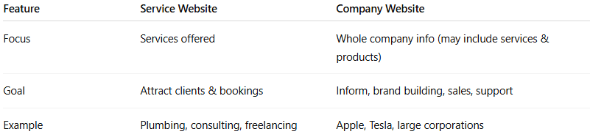
Feature | Service Website | Company Website
Focus | Services offered | Whole company info (may include services & products)
Goal | Attract clients & bookings | Inform, brand building, sales, support
Example | Plumbing, consulting, freelancing | Apple, Tesla, large corporations

